BASIC INFORMATION

Project Name : COLLEGE MANAGEMENT SYSTEM [CMS]
Intern Name: Ms. NEEKITA PATIL
Company Name: INNO FORTUNE IT PVT. LTD
Mentor Name: Ms. NIKITA MAM
Start Date: 21 feb 2026

Day1 Topics
Project overview, objective, scope, finalization.

1. Project Overview
The CMS Project is designed to study and analyze the existing system processes and identify gaps or limitations in the current workflow. Based on this analysis, the project aims to design and propose an optimized, efficient, and user-friendly system.
On the first day of the internship, an overall introduction to the project was provided, including its purpose, workflow, and expected outcomes.

2. Project Objective
The main objectives of the CMS Project are:
- To understand the current system and its working process
- To identify problems, inefficiencies, and improvement areas
- To design a well-structured and optimized solution
- To ensure the system is user-friendly and easy to operate
- To perform proper documentation for future development and maintenance

3. Project Scope
The scope of the CMS Project includes:
- Analysis of the existing system
- Requirement gathering and data collection
- Module planning and system structuring
- Preparation of technical and functional documentation
- Validation of system functionality
The project does not focus on deployment at this stage; it mainly emphasizes analysis, planning, and documentation.

4. Key Activities Performed on Day 1

On the first day of the internship, the following activities were carried out:
- Introduction to the organization and internship guidelines
- Explanation of the CMS Project and task assignment (CMS)
- Understanding the project objective and expected deliverables
- Discussion on project scope and limitations
- Finalization of project topic and documentation structure

5. Outcome of Day 1

By the end of Day 1:
- Clear understanding of the project requirements was achieved
- Project objectives and scope were finalized
- Documentation format and workflow were discussed
- A roadmap for upcoming development and documentation activities was prepared

6. Conclusion
Day 1 of the internship focused on gaining a complete overview of the CMS Project. The session helped in understanding the purpose, scope, and expectations of the project. This foundation will support effective implementation, documentation, and validation in the upcoming internship days.

Day 2 : Topics
Requirement Analysis (Functional & Non-Functional)

Introduction
The second day of the internship was focused on requirement analysis, which is a critical phase of system development. Requirement analysis helps in understanding what the system should do and how it should perform. On this day, both functional and non-functional requirements of the CMS Project were identified and documented.

Requirement Analysis Overview
Requirement analysis is the process of gathering, analyzing, and documenting the needs of users and stakeholders. This phase ensures that the system meets user expectations and works efficiently under real-world conditions.
The analysis was divided into:
- Functional Requirements
- Non-Functional Requirements

Functional Requirements
Functional requirements define the core features and operations of the system. The identified functional requirements for the CSM Project are:

- User login and authentication
- Role-based access control (Admin/User)
- Data entry and management
- View, update, and delete records
- Search and filter functionality
- Report generation
- Validation of user input data
- Secure data storage and retrieval
These requirements ensure that the system performs all required business operations correct

Non-Functional Requirements

Non-functional requirements describe how well the system performs rather than what it does. The non-functional requirements identified are:
- Performance: The system should respond quickly to user actions
- Security: User data must be protected from unauthorized access
- Usability: The interface should be simple and user-friendly
- Reliability: The system should work without failure under normal conditions
- Scalability: The system should support future enhancements
- Availability: The system should be accessible during working hours
- Maintainability: The system should be easy to update and maintain

Requirement Gathering Techniques Used

The following techniques were used to gather requirements:
- Discussion with project mentor
- Understanding problem statements
- Reviewing existing system workflow
- Analyzing user expectations

Outcome of Day 2
By the end of Day 2:
- Functional and non-functional requirements were clearly identified
- System expectations were documented
- A strong foundation was created for system design and development
- Requirement clarity reduced the risk of future changes

Conclusion
Day 2 of the internship was dedicated to requirement analysis, which plays a vital role in the success of the CMS Project. Proper identification of functional and non-functional requirements ensures that the system will be efficient, secure, and user-friendly.

Day 3: Topics
User Roles & Module Finalization

1. Introduction
- Day 3 focused on identifying different users of the system
- Finalized the main modules of the College Management System
- This helps in proper system planning and access control

2. User Roles in CMS
User roles define who can use the system and what they can do.
Admin
- Full access to the system
- Manages students, staff, and courses
- Controls user permissions
- Generates reports
Faculty / Staff
- Login to the system
- Mark student attendance
- Upload marks and results
- View assigned classes
Student
- Login to the system
- View attendance and marks
- Check timetable and notices
- Update basic profile details

3. Importance of User Roles
- Improves system security
- Prevents unauthorized access
- Clearly defines responsibilities
- Makes system usage easy

Module Finalization in CMS

The following modules were finalized:
1. Login Module
- Allows users to login using username and password
- Checks user authentication
- Provides access based on user role
- Keeps system secure

2. Student Management Module
- Stores student personal and academic details
- Allows adding, updating, and deleting student records
- Helps in searching student information
- Maintains complete student database

3. Faculty Management Module
- Stores faculty and staff details
- Allows admin to manage staff records
- Assigns subjects and classes to faculty
- Helps track faculty information easily

4. Attendance Module
- Records daily student attendance
- Allows faculty to mark attendance
- Shows attendance reports
- Helps track student presence

5. Examination Module
- Manages exam schedules
- Allows faculty to enter marks
- Generates student results
- Helps track academic performance

6. Fee Management Module
- Stores student fee details
- Tracks paid and pending fees
- Generates fee receipts
- Helps manage financial records

7. Library Module
- Manages book records
- Tracks issue and return of books
- Maintains due dates and fines
- Helps in smooth library operations

8. Notice Module
- Publishes important notices
- Displays announcements to users
- Allows admin or staff to post updates
- Keeps students informed

5. Importance of Module Finalization
- Divides the system into smaller sections
- Makes development easy
- Helps in better planning
- Reduces confusion

6. Outcome of Day 3
- User roles were finalized
- CMS modules were clearly defined
- System structure became clear

7. Conclusion
Day 3 helped in identifying user roles and finalizing the modules of the College Management System, which is important for secure and organized system development.

Day 4: Topics
Use Case Diagram & Module Mapping

1.Use Case Diagram

A Use Case Diagram shows:
- Who uses the system (called Actors)
- What actions they can do in the system

In a College Management System (CMS), there are three main actors:

Actors in CMS
- Admin
- Faculty / Staff
- Student

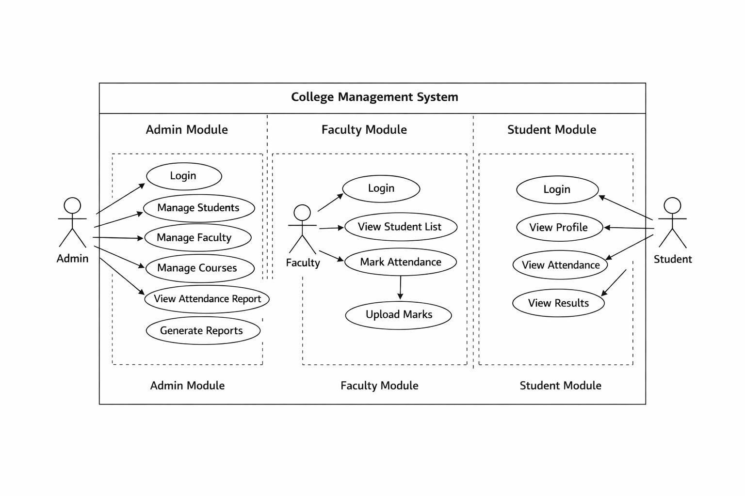
Authentication diagram

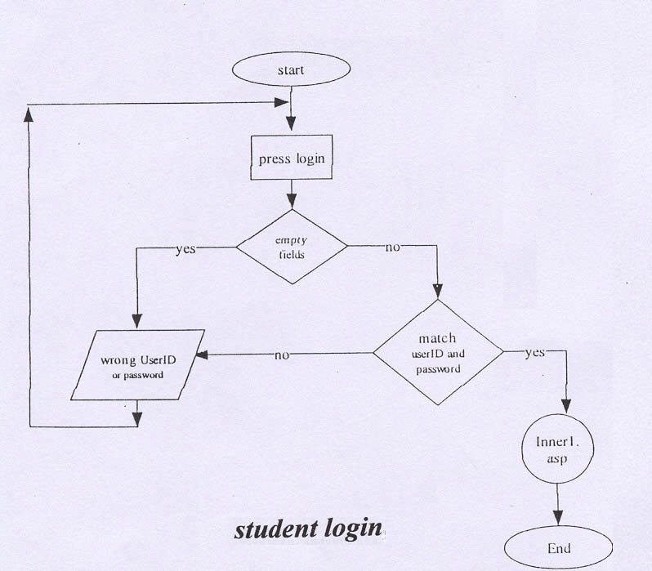

Admin controls the full system.
- Add / update students and faculty
- Manage courses and subjects
- Generate reports and results

Faculty / Staff
Faculty handles academic activities.
- Upload attendance
- Enter marks
- View student details

Student
Students use the system to view information.
- View attendance
- View marks and results
- Update personal profile

2. Module Mapping
Module Mapping means dividing the system into small parts (modules) and connecting them with users.

Main Modules in CMS
1. Admin Module
- Manage students
- Manage faculty
- Manage courses
- System settings

2.Faculty Module
- Attendance management
- Marks entry
- Student performance tracking

3. Student Module
- View attendance
- View marks
- Profile management

Relation Between Use Case & Modules
- Use Case Diagram → shows actions
- Module Mapping → shows system structure

Actor | Related Module
Admin | Admin Module
Faculty | Faculty Module
Student | Student Module
Conclusion
On Day 4, the Use Case Diagram helped to understand user roles and system functions, while Module Mapping helped to understand how the system is divided into modules.
Both diagrams make the College Management System easy to understand and design.

